Dear Sir,
When I did freesurfer for structure analysis, I was confused by some steps and results. The analysis stream was:
1st: check data orientation
2nd : convert nii.gz to mgz
3rd: recon-all –all –subjid sub01
After these steps finished , I checked skullstrip, segmentation quality. The problems as following:
1st: skullstrip result not very well, almost need manually operation.
After manually operation, I run:
recon-all –autorecon2 –autorecon3 –subjid sub01
2nd: parts of white surface and pial surface not very exactly. I only did adding control points to modify white surface, then I run:
Recon-all –autorecon2-cp –autorecon3 –subjid sub01 brainmask.mgz
Several parts of pial surface exit errors. I added these as screenshot:
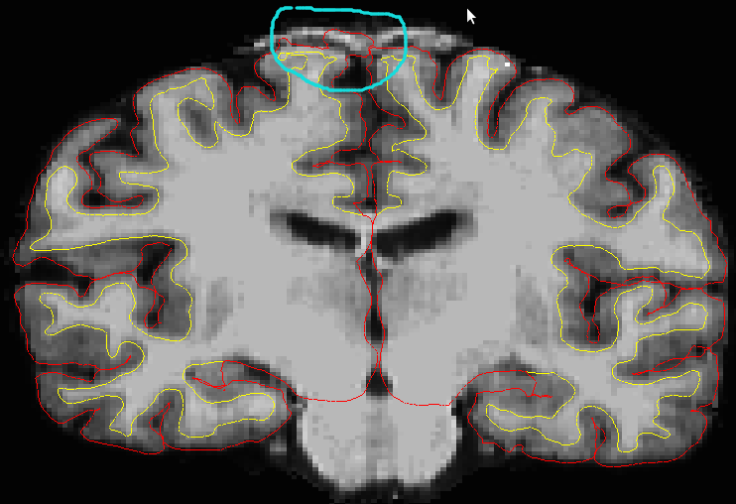
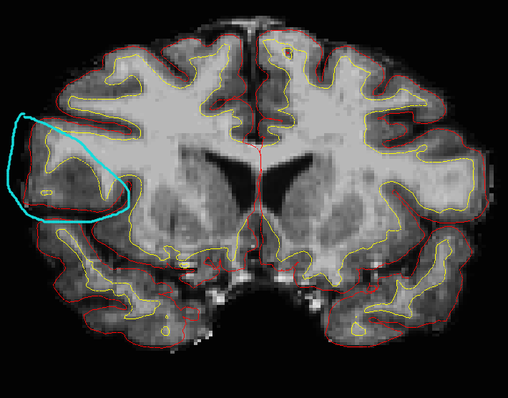
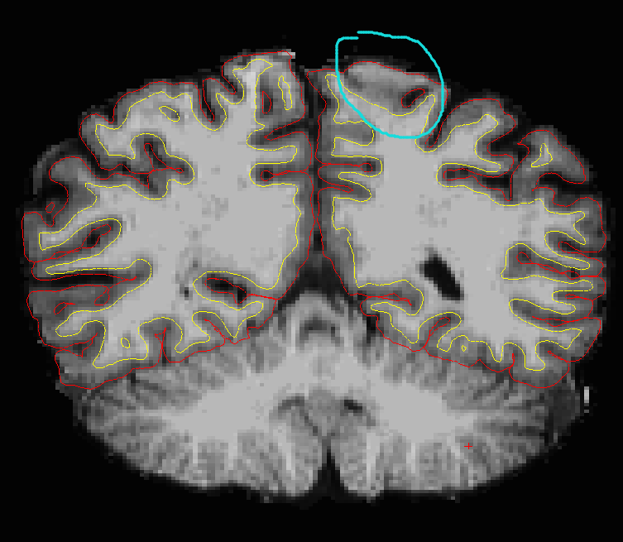
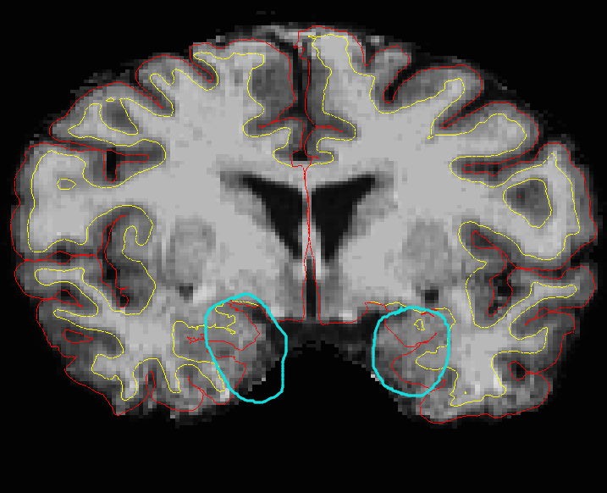

Such issues, I should add control points for pial surface as white surface did (or how I correct or edit pial; still use tkmedit tool?) ? Then I run:
recon-all –autorecon2-pial –autorecon3 sub01 ?
If white surface and pial surface all needed manually operated, whether I could do like this: I add control points (-cp), edit wm (-wm), correct pial (-pial ) at the same time, then I run:
recon-all –autorecon2-cp –autorecon2-wm –autorecon-pail –autorecon3 sub01?

