Hello, Freesurfer experts:
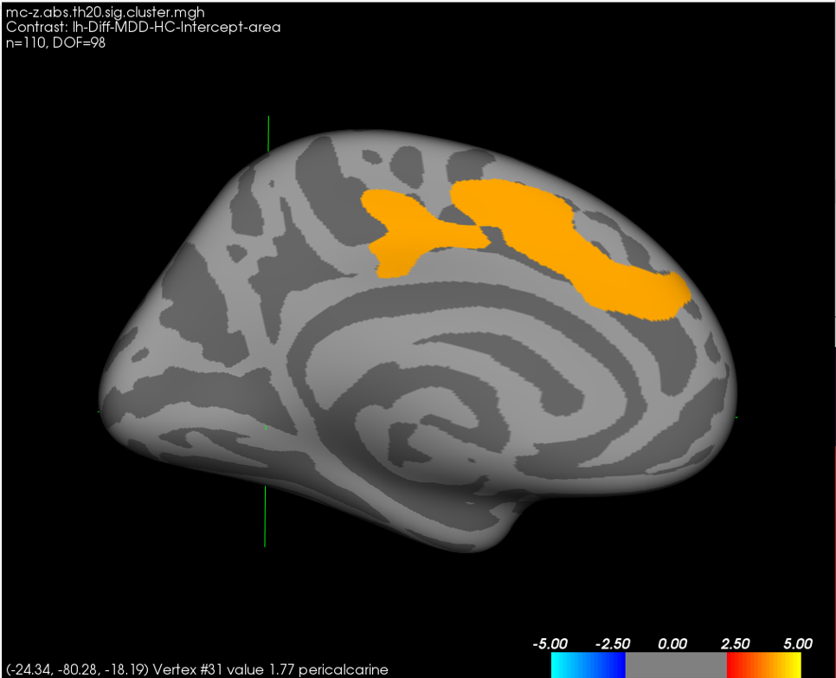
I have performed group analysis using QDEC in Freesurfer 6.0 to examine difference between MDD and HC group in surface area with age, sex, and eTIV as covariates and identified one significant region (MDD > HC, warm color, shown in Figure.1).

Figure.1 Statistically significant regions where averaged surface area is differed between MDD and HC. The significance value is positive, which mean the surface area in MDD is bigger than that in HC.

Then I drew this ROI as a label (defined as lh.daccarea.label), mapped the label to all subjects, and extracted the average surface area of this ROI from every subject. The following is the command:
>> mri_label2label --srclabel lh.daccarea --srcsubject fsaverage –trgsubject M001 --trglabel lh.daccarea --regmethod surface --hemi lh
>>mris_anatomical_stats -l M001/label/lh.daccarea.label -f M001/stats/lh.untitled.stats M001 lh
>> aparcstats2table --hemi lh --subjects 001 002 003 004 --parc lh.daccarea --meas area --tablefile lh.daccarea.stats.txt

However, when I conducted a GLM model analysis in SPSS with age, sex, and eTIV as covariates, the result (MDD<HC) is opposite to the QDEC result. And the results of SPSS can be seen in Figure2. I am writing to see if you could kindly provide me with information regarding this question. Is my analysis set up correctly in QDEC for what I’m trying to do?

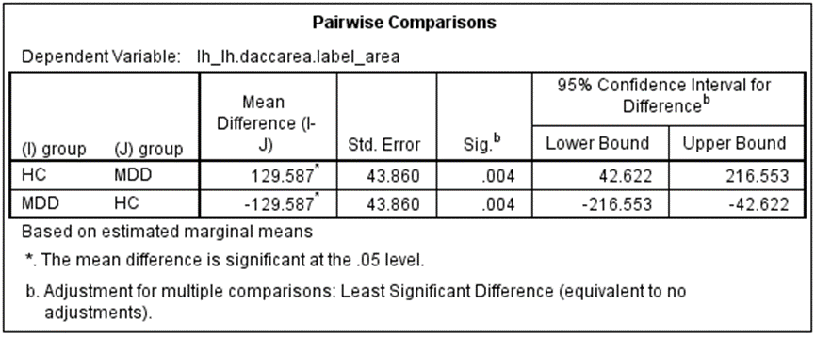
Figure.2. The results of SPSS, as shown in picture, the surface area of MDD is smaller than health group.

Following is some information of QDEC analysis:
1.Fsgd:
GroupDescriptorFile 1
Title lh_area
MeasurementName area
Class groupMDD-genderMALE
Class groupHC-genderMALE
Class groupMDD-genderFEMALE
Class groupHC-genderFEMALE
Variables age TIV
Input M001 groupMDD-genderFEMALE 16.000000 1455607.658680
And so on...

2.contrast matrix DODS
Thank you for your kindness, and your prompt attention to this letter will be highly appreciated.

Sincerely
Weijie Bao
Postgraduate
Huaxi MR Research Center(HMRRC)
Department of Radiology
West China Hospital of Sichuan University
Chengdu, Sichuan, PR China, 610041
Tel: 86-13594527190
Email: 13594527190@163.com

