Subject 1: SPGR Sequence only - Recon all output | Subject 1: SPGR with Flair - Recon all output
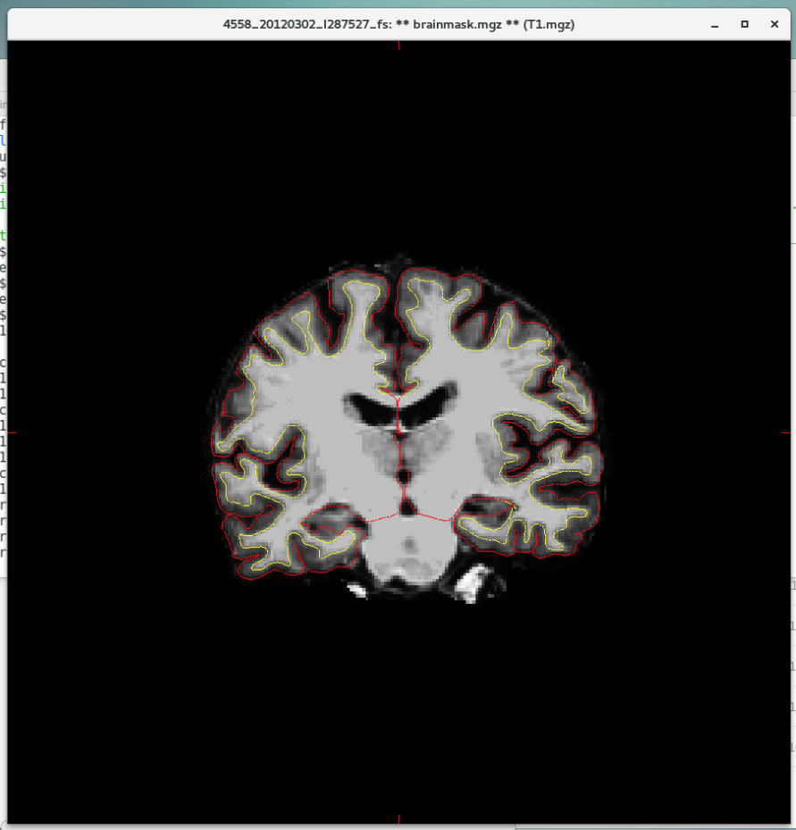 | 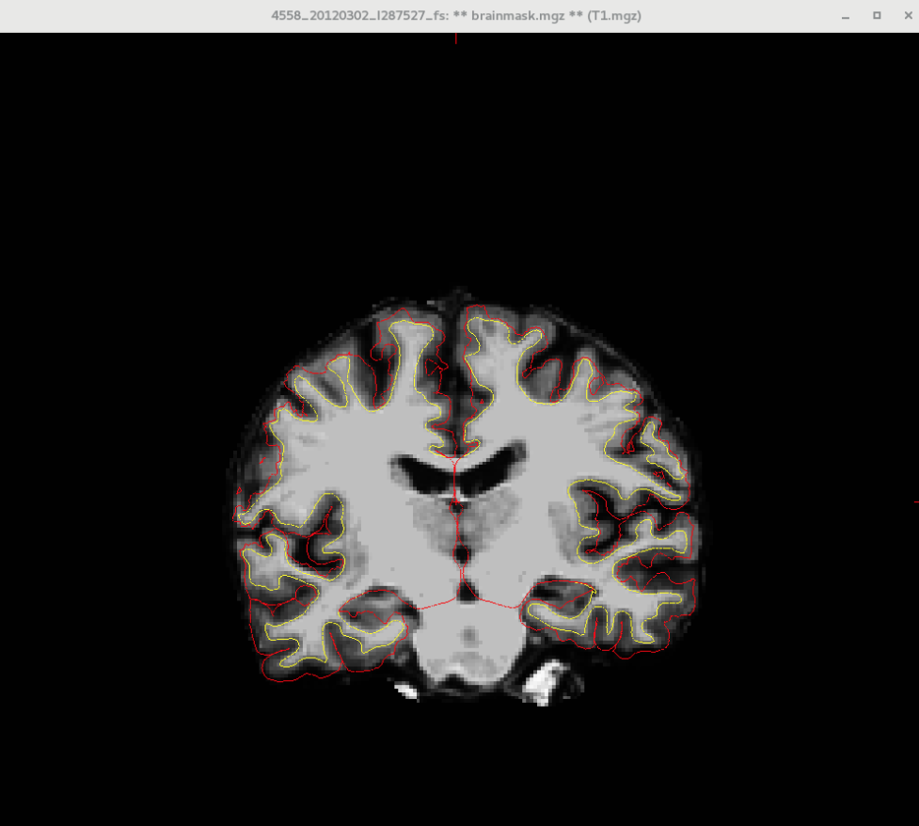

Subject 2: SPGR Sequence only - Recon all output | Subject 2: SPGR with Flair - Recon all output
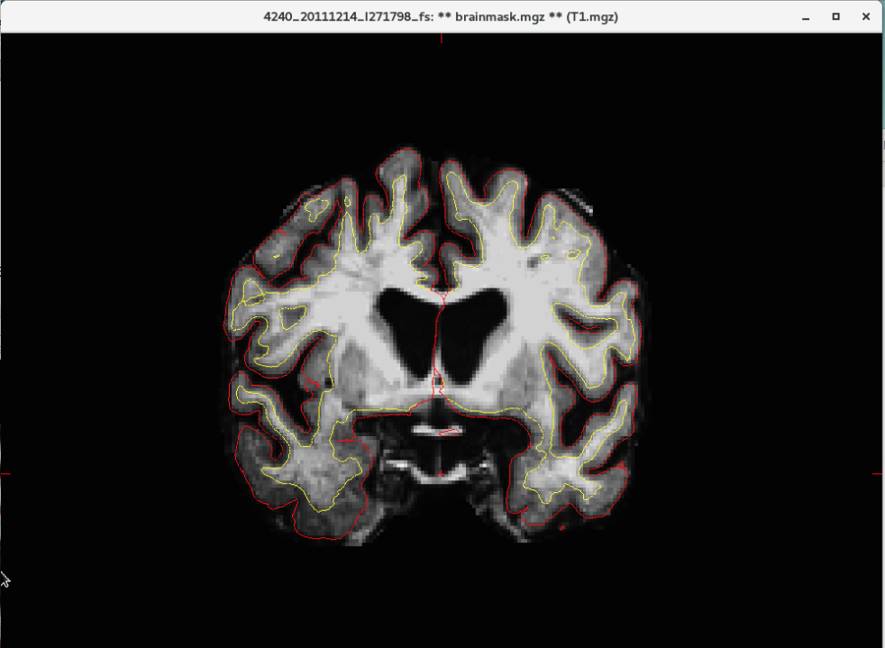 | 